Chatbots

In this project you will make a chatbot that can answer questions about a topic of your choice.

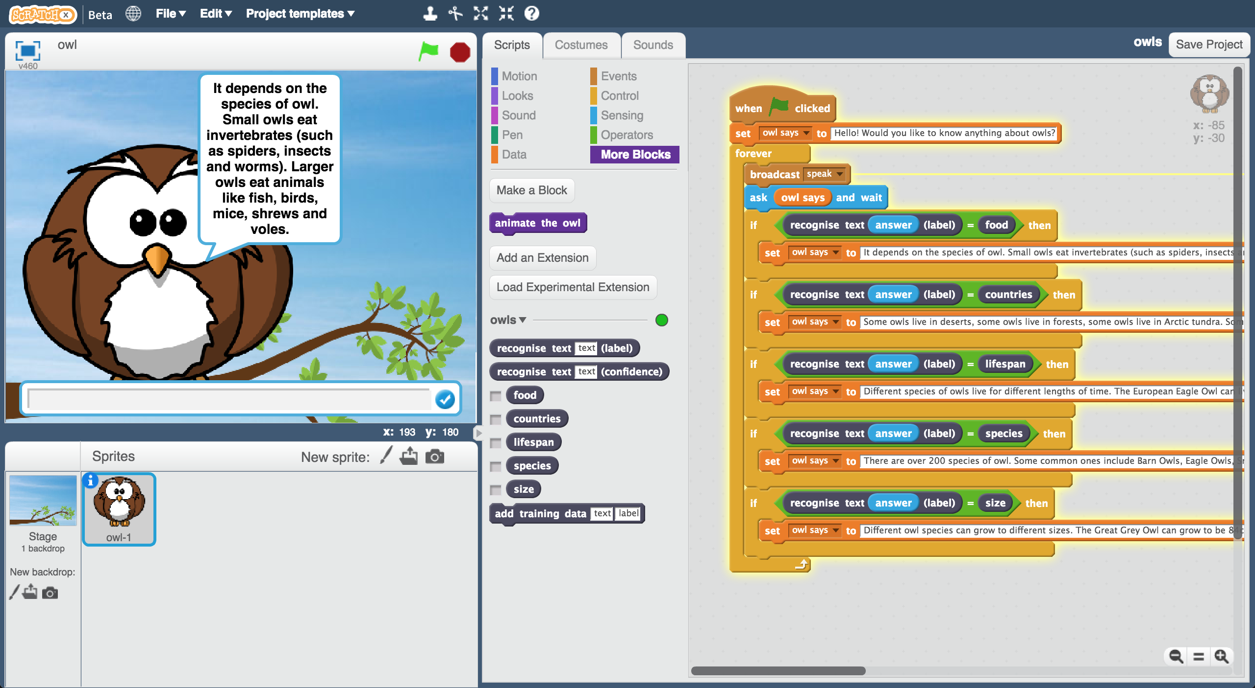

Creative Commons LicenceThis project worksheet is licensed under a Creative Commons Attribution Non-Commercial Share-Alike License

http://creativecommons.org/licenses/by-nc-sa/4.0/

1. Decide on **a topic** for your chatbot  
   Choose something that you know well enough to be able to answer questions about.   
   *It could be a place (e.g. The town where you live?)  
   It could be an animal (e.g. Tigers? Dinosaurs?)  
   It could be an organisation (e.g. Your school)  
   It could be something from history (e.g. Vikings? Romans?)  
   For the rest of this worksheet, I’ll be using* ***owls***
2. Think of **five things** someone might ask about your topic  
   *e.g. for* ***owls****, this could be:  
   * What do owls eat?  
   * Where in the world do owls live?  
   * How long do owls live?  
   * What types of owls are there?  
   * How big do owls grow?*
3. Go to <https://machinelearningforkids.co.uk/> in a web browser
4. Click on “**Get started**”
5. Click on “**Log In**” and type in your username and password  
   *If you don’t have a username, ask your teacher or group leader to create one for you.  
   If you can’t remember your username or password, ask your teacher or group leader to reset it for you.*
6. Click on “**Projects**” on the top menu bar
7. Click the **“+ Add a new project**” button.

1. Name your project and set it to learn how to recognise “**text**”.   
   Click the “**Create**” button  
   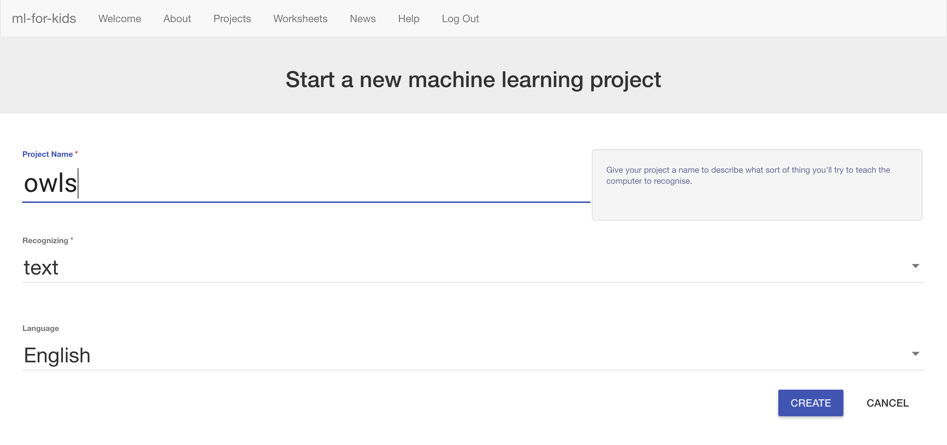
2. Click on your new project in the projects list
3. Click the **Train** button.  
   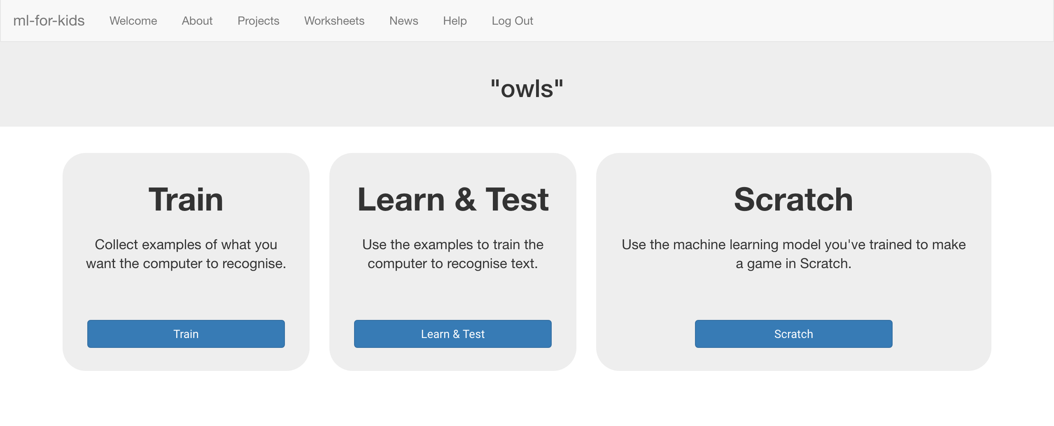
4. Click the “**+ Add new label**” button  
   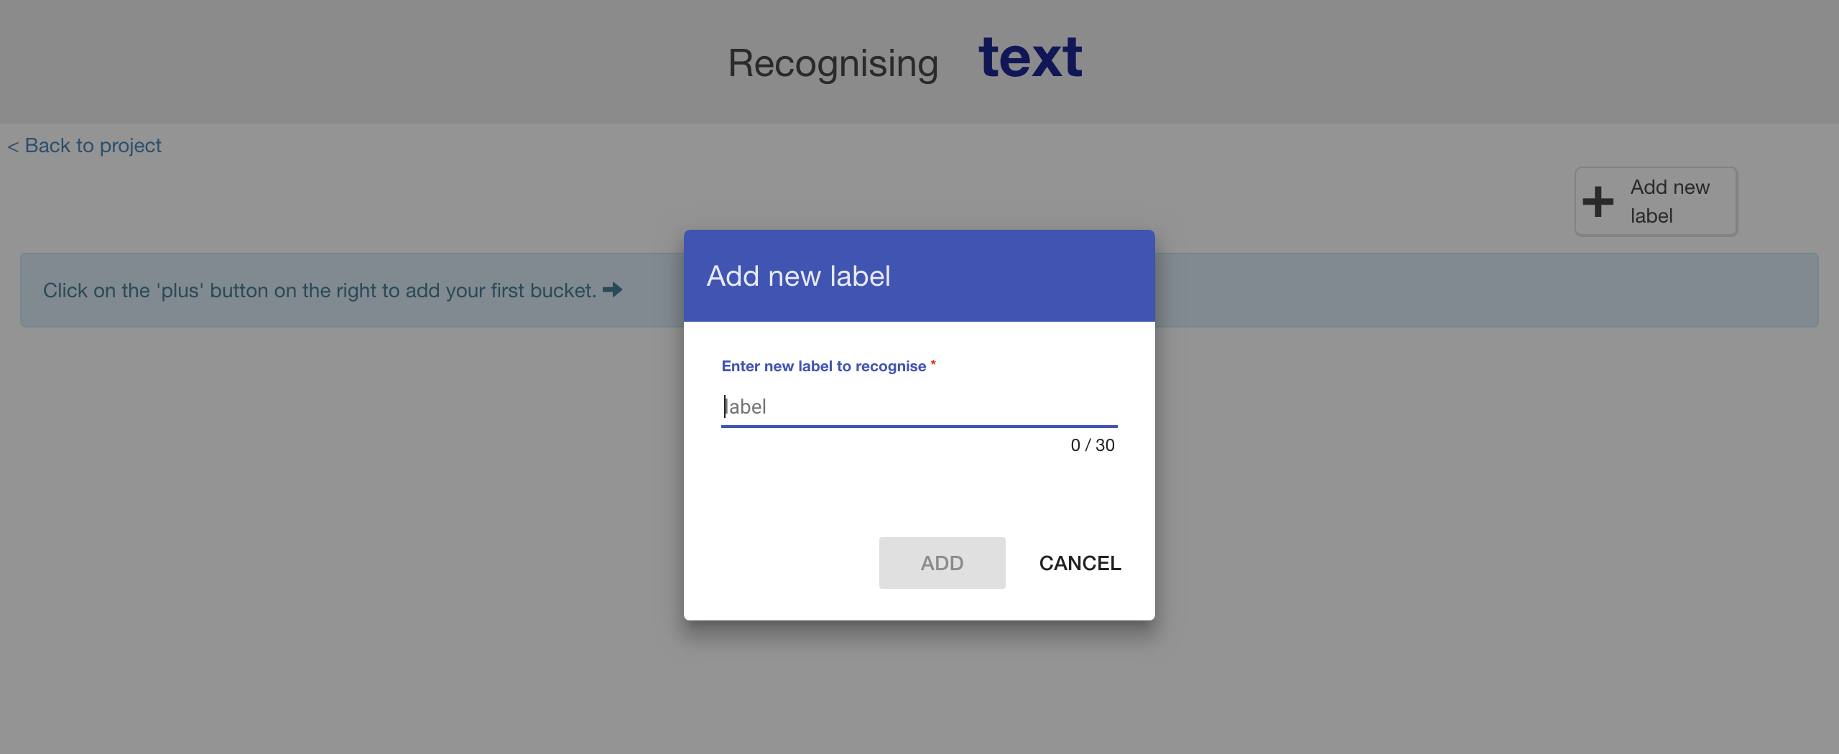
5. Type in **one word** that sums up the first of your things from Step 2, then click **Add**.   
   *I used “food” to sum up “What do owls eat?”*  
   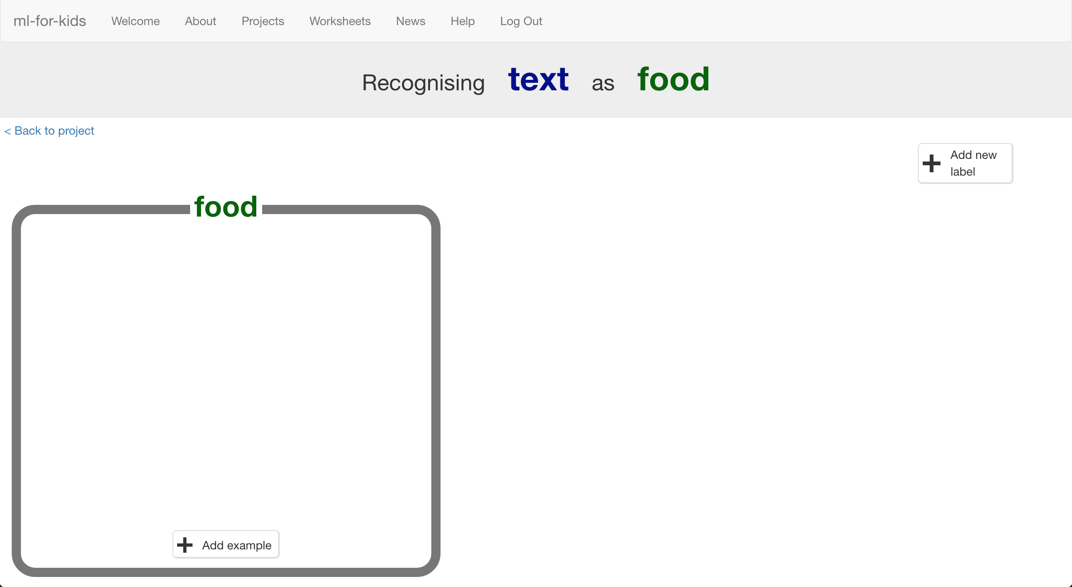
6. Do that again for all of the things in your list from Step 2  
   *The words you choose don’t really matter, as long as* ***you*** *understand what they mean.*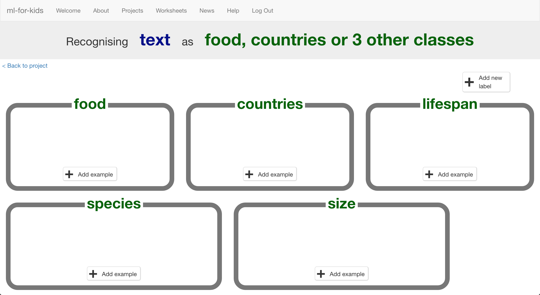

1. Click the “**+ Add example**” button in one of the buckets
2. Type in an example of how someone might ask that question  
   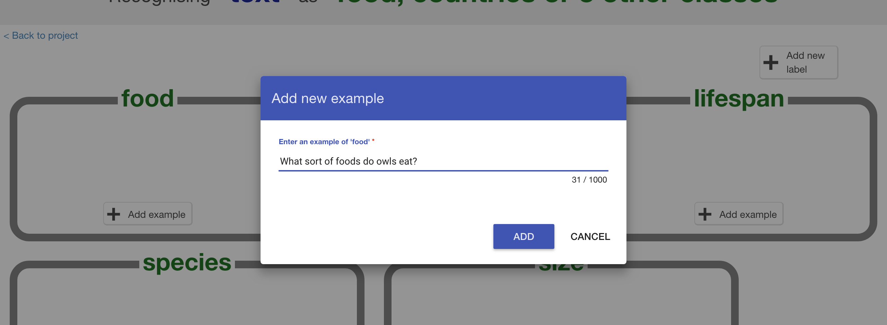
3. Click “**Add**”
4. Repeat until you’ve got **five examples** of how to ask that question.  
   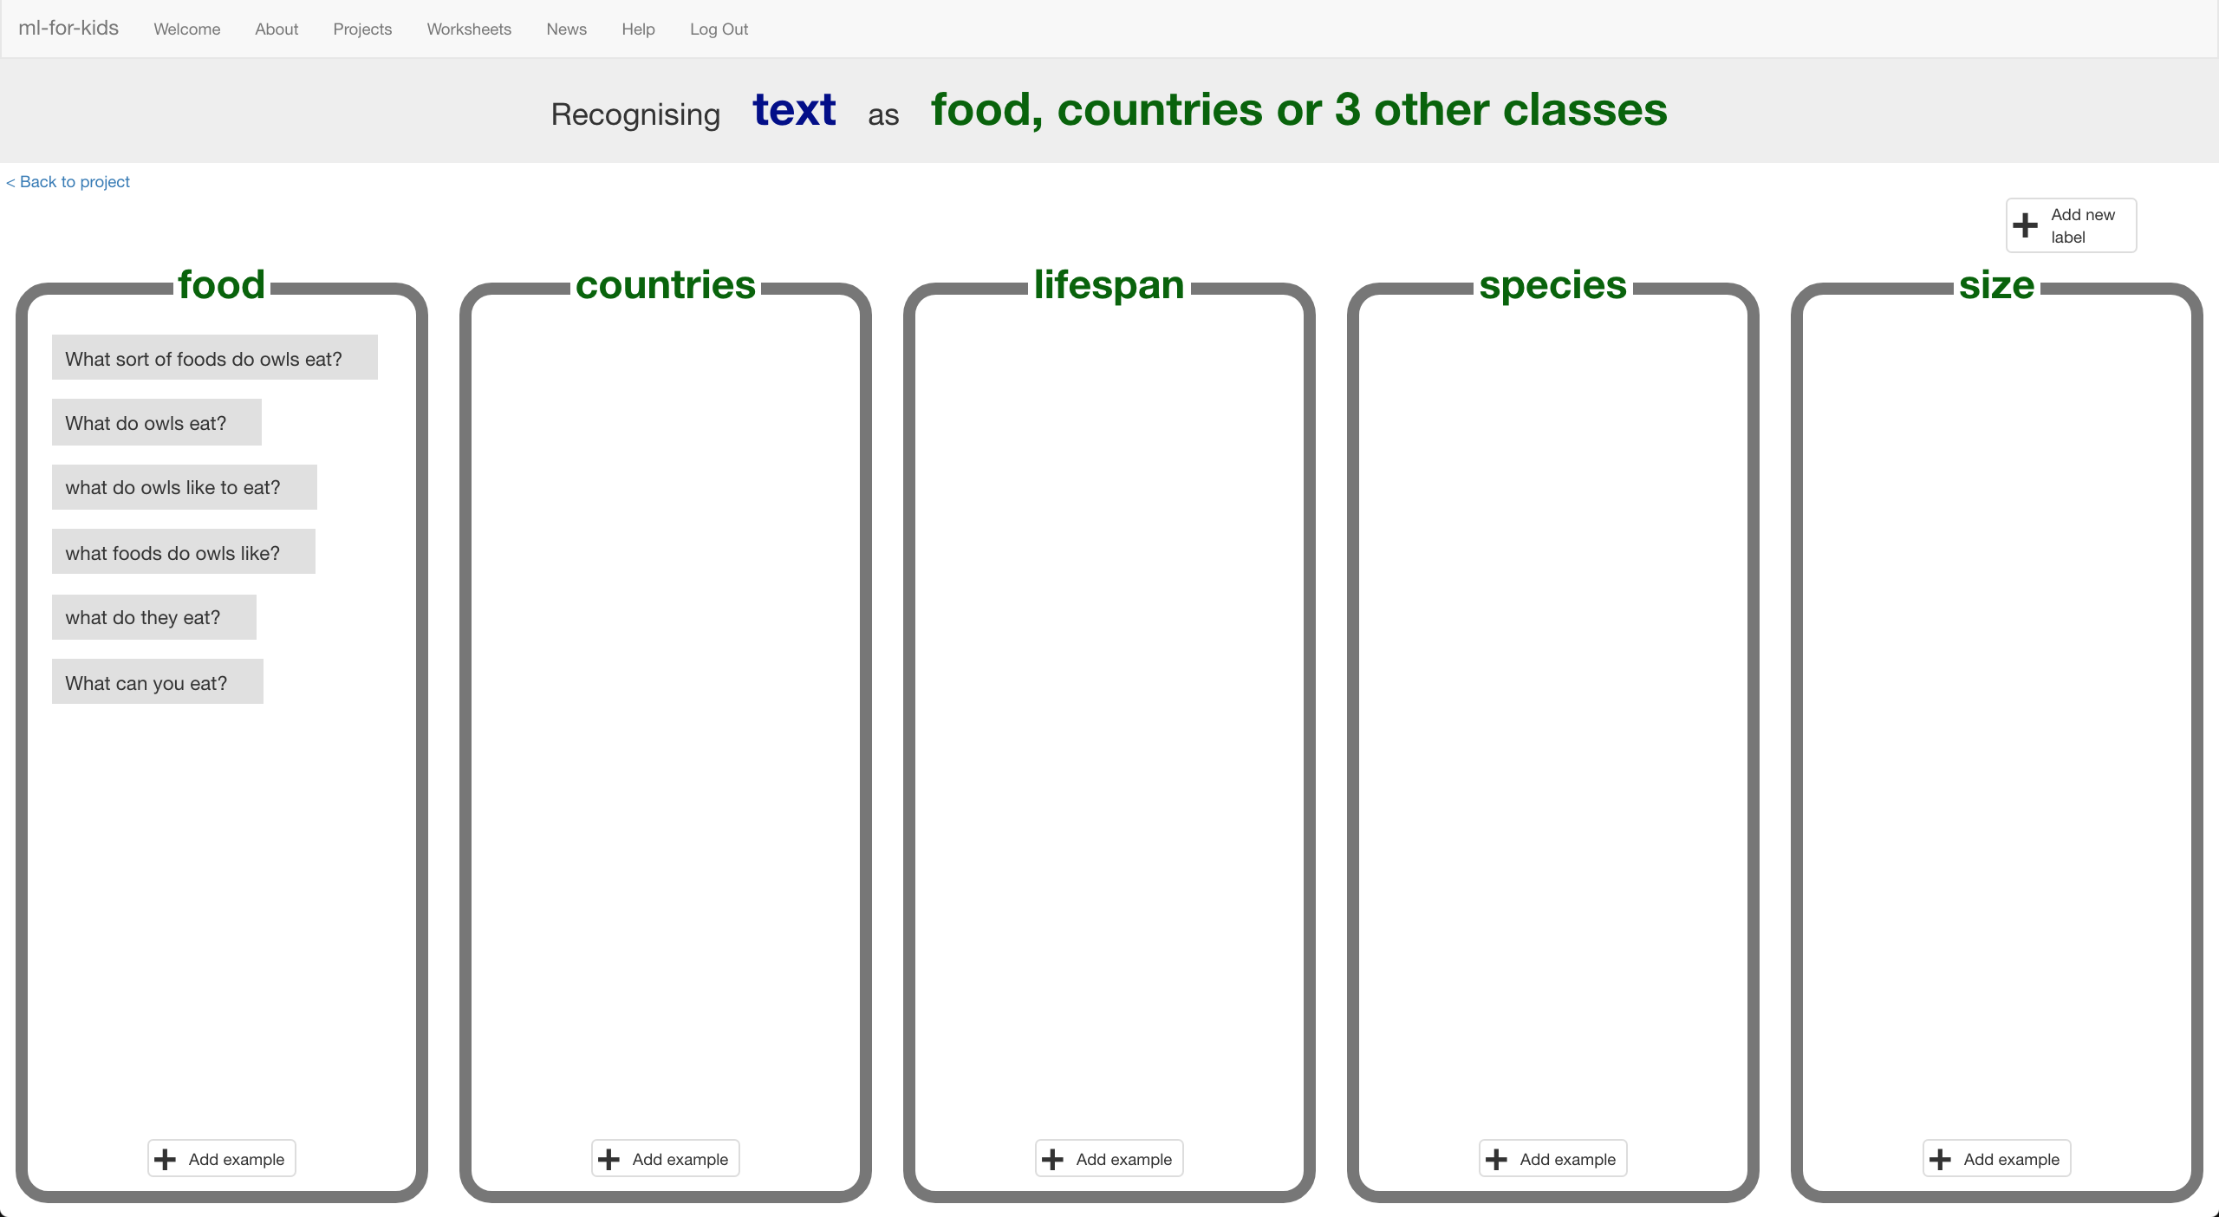
5. Repeat until you’ve got at least five examples in every bucket  
   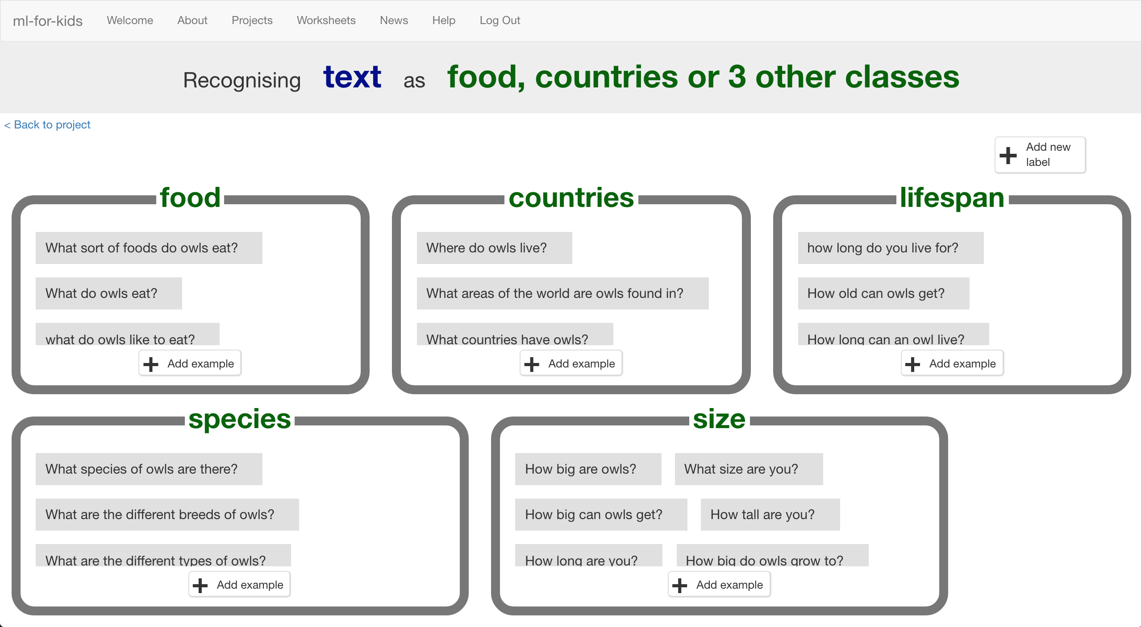
6. Click on the “**< Back to project**” link
7. Click the “**Learn & Test**” button
8. Click the “**Train new machine learning model**” button  
   *As long as you’ve collected enough examples, the computer should start to learn how to recognise questions from the examples you’ve given to it.*  
   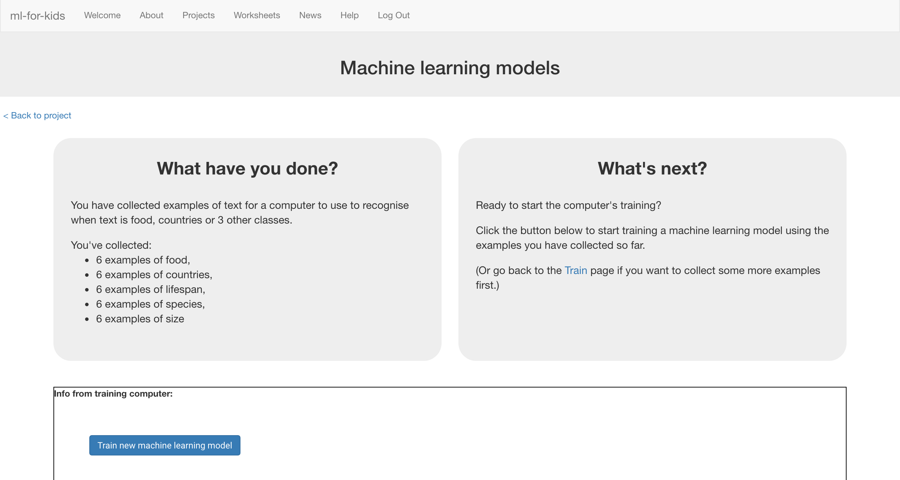
9. Wait for the training to complete.   
   *This might take a couple of minutes.  
   It’s finished once you see the “status” change to “Available”*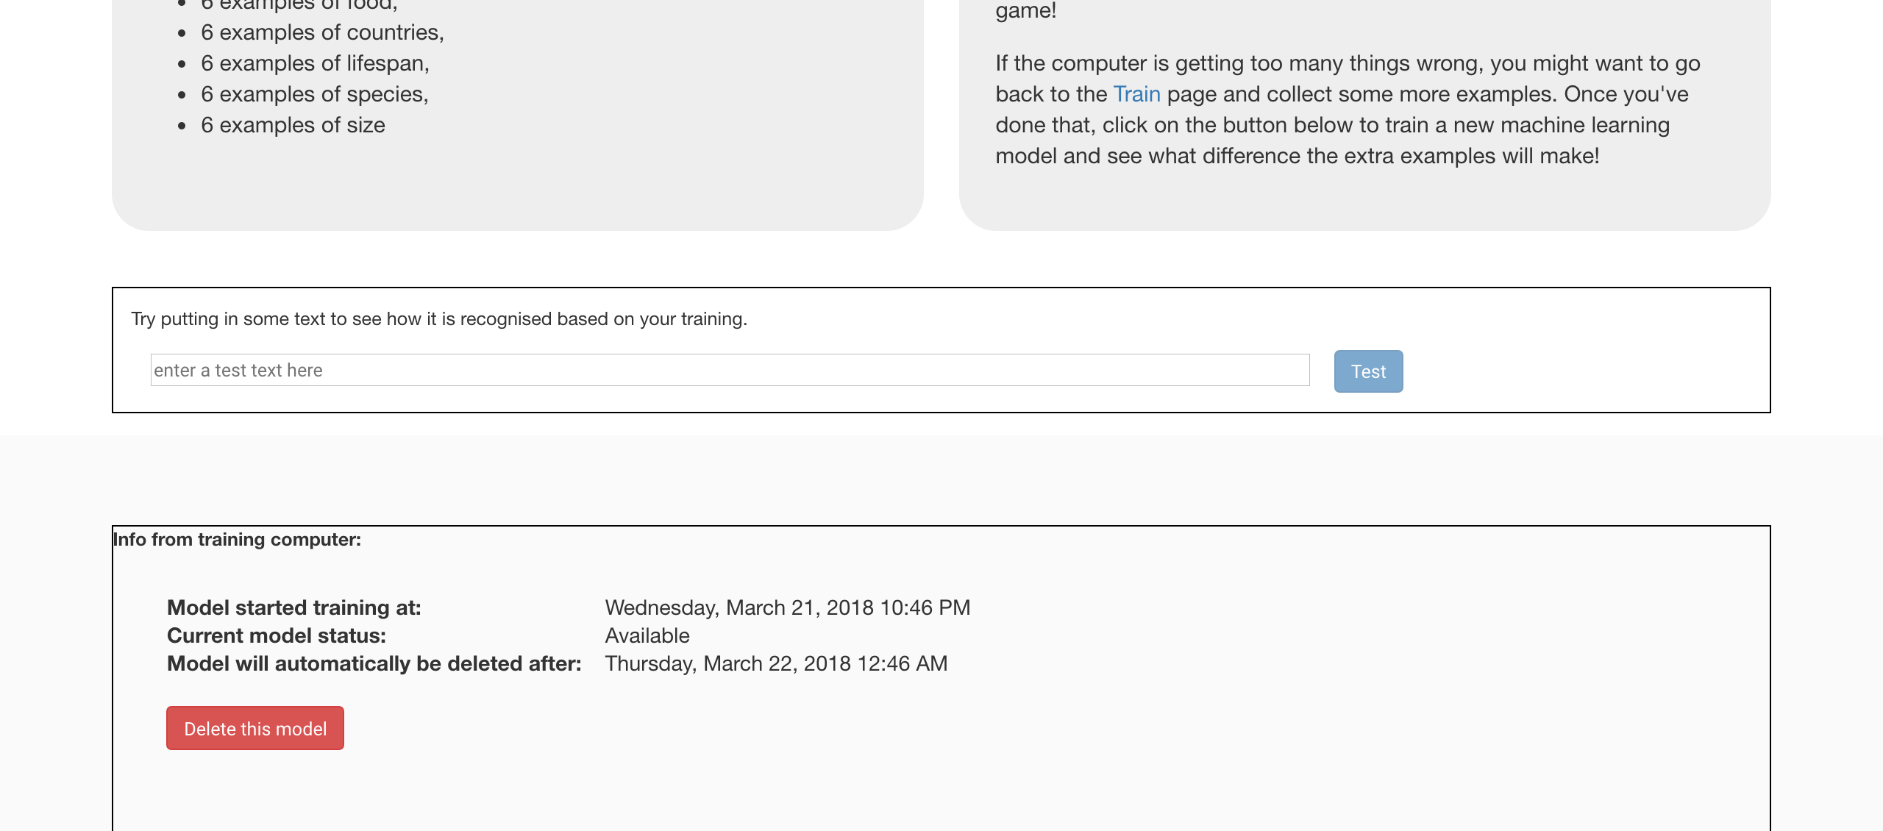
10. Click the “**< Back to project**” link
11. Click the “**Scratch**” button
12. Click the “**Open in Scratch**” button  
    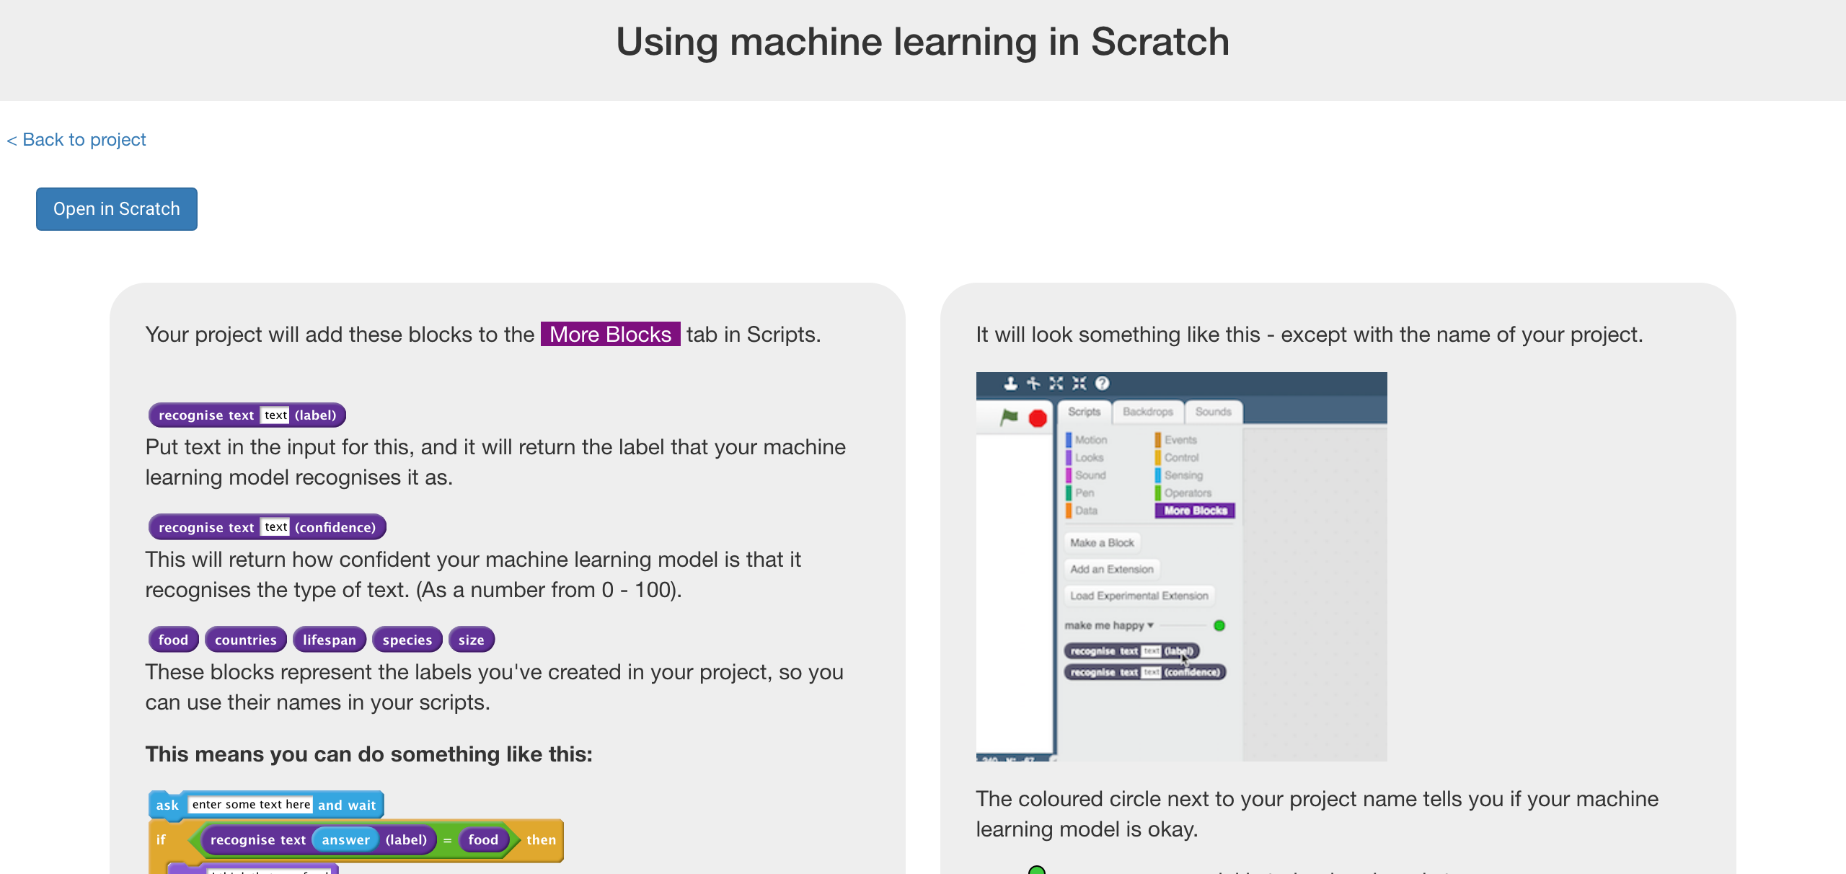
13. Click the “**Open in Scratch**” button to launch the Scratch editor.   
    *You should see new blocks in the “More blocks” section from your project.*  
    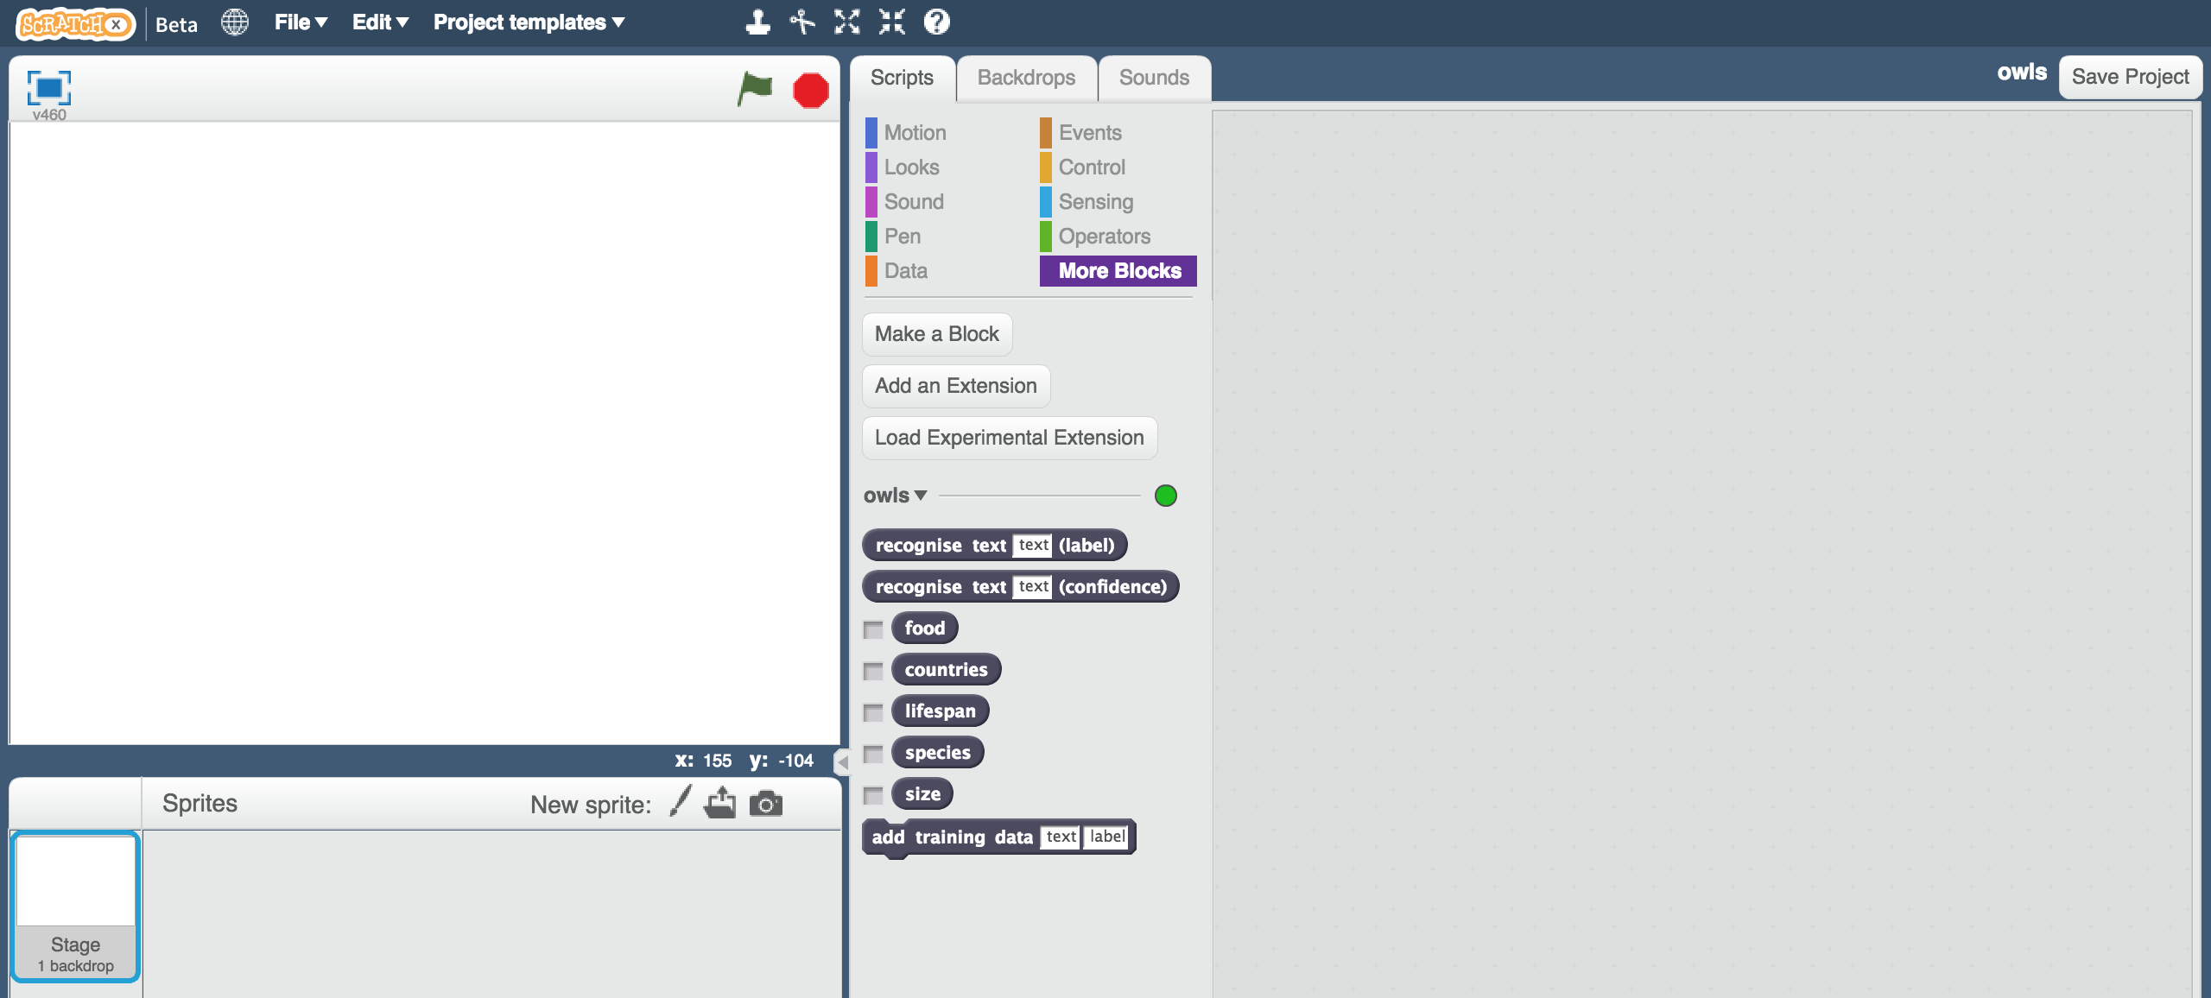
14. Click “**Project templates**” -> “**Owls**” to open the project template  
    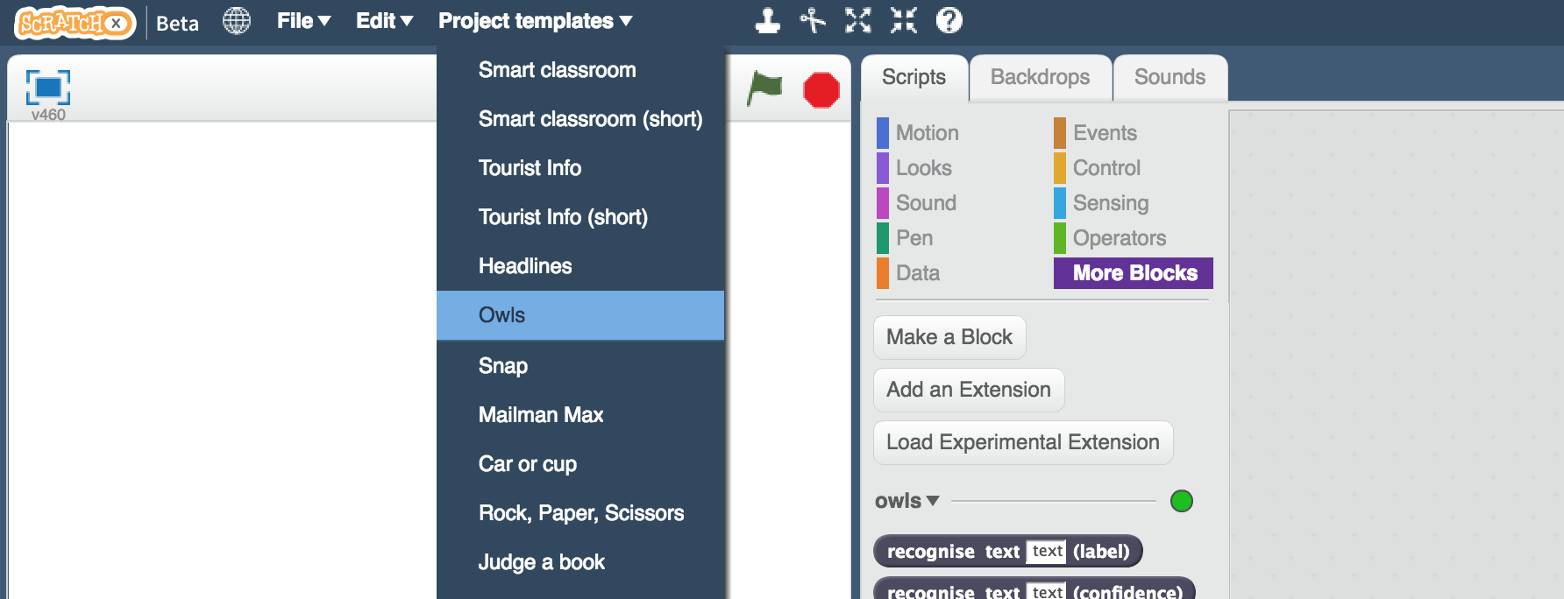
15. Create this little snippet of script but don’t attach it to anything yet  
    *Make sure you choose “owl says” for the orange block.*   
    
16. Duplicate it four times  
    *Right-click on it, and click “Duplicate”*   
    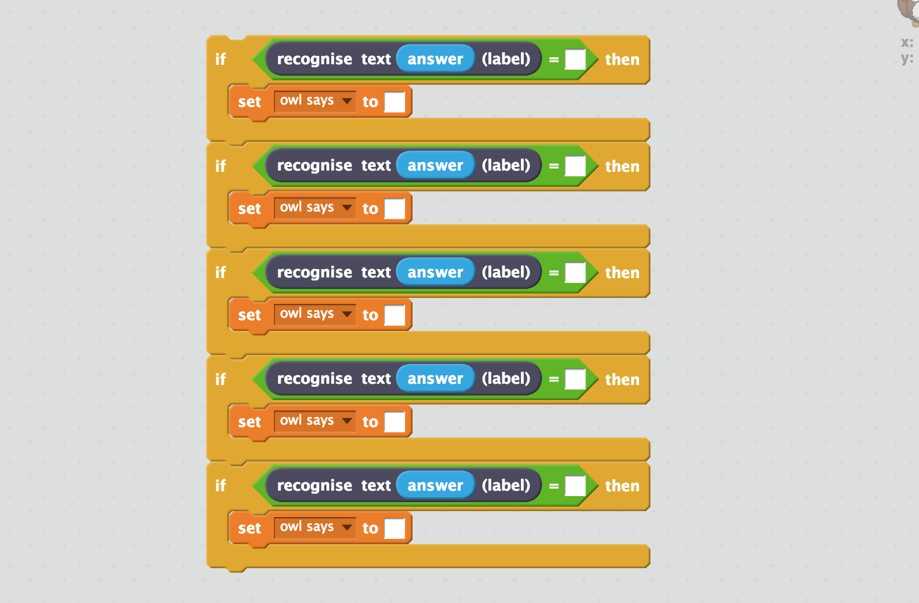
17. Fill in each copy of the block   
    *Drag the label for one of your questions into the top space, and   
    Type the answer to the question into the bottom space*  
    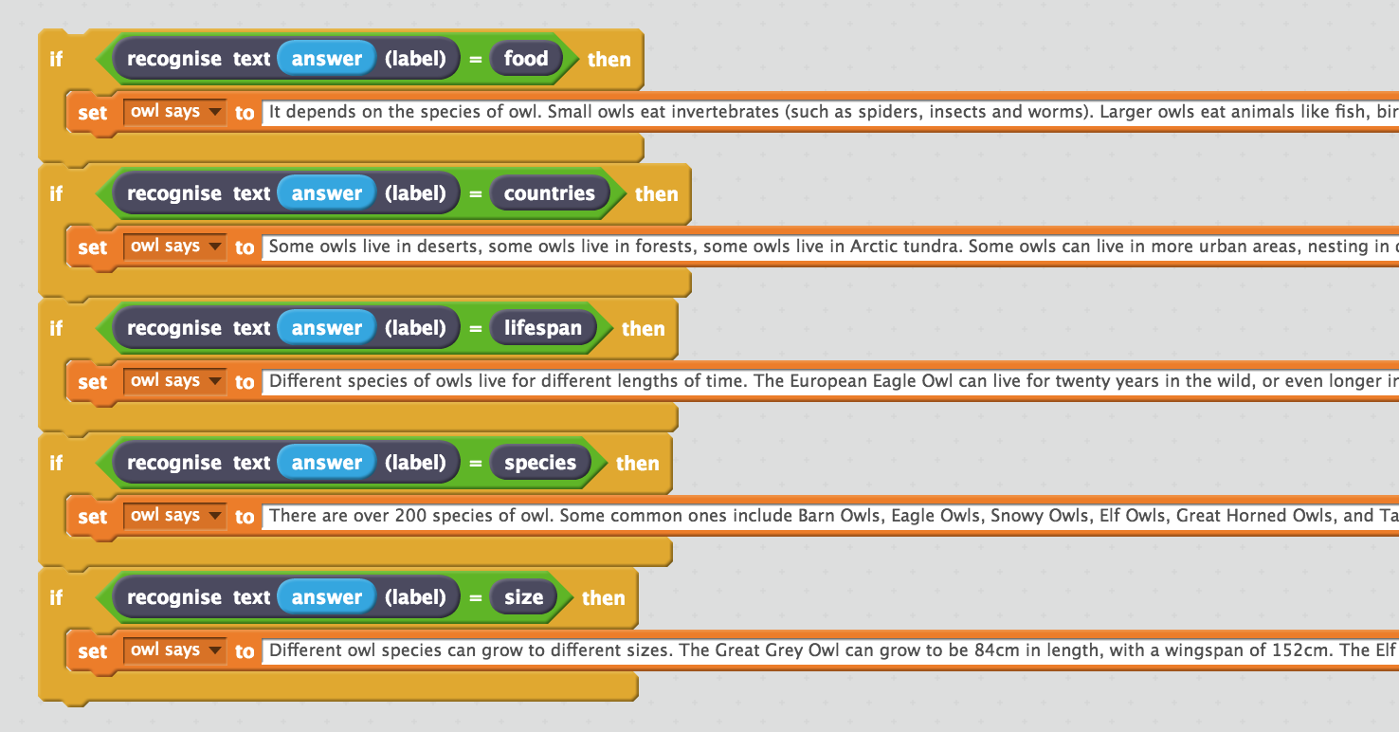
18. Drag this new block into the Green Flag block prepared for you.   
    *Replace the “Sorry. I haven't been taught anything yet.” block with your new chunk of script.  
    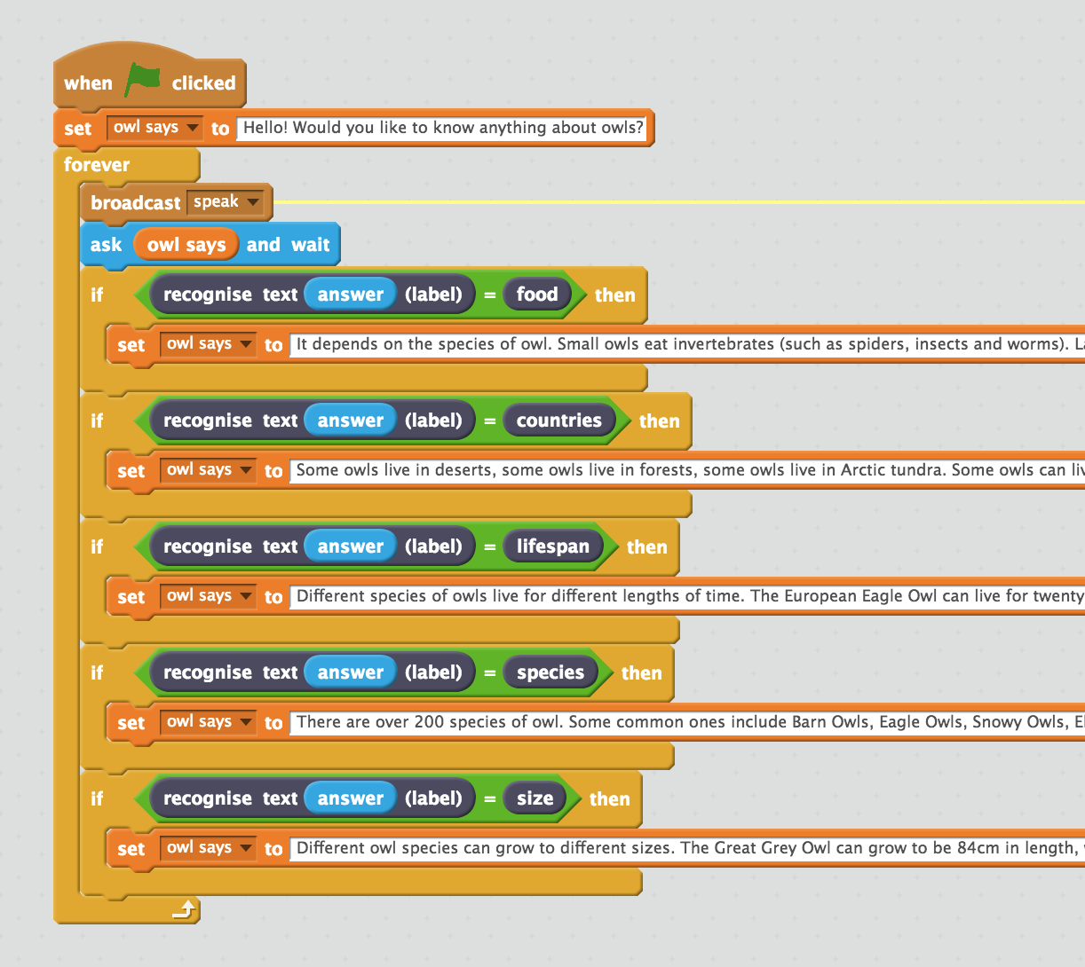*
19. Draw your chatbot  
    *Unless you’ve chosen* ***owls*** *as a topic, you’ll need to draw your own character  
    If you provide different costumes, you can animate your character while it talks.   
    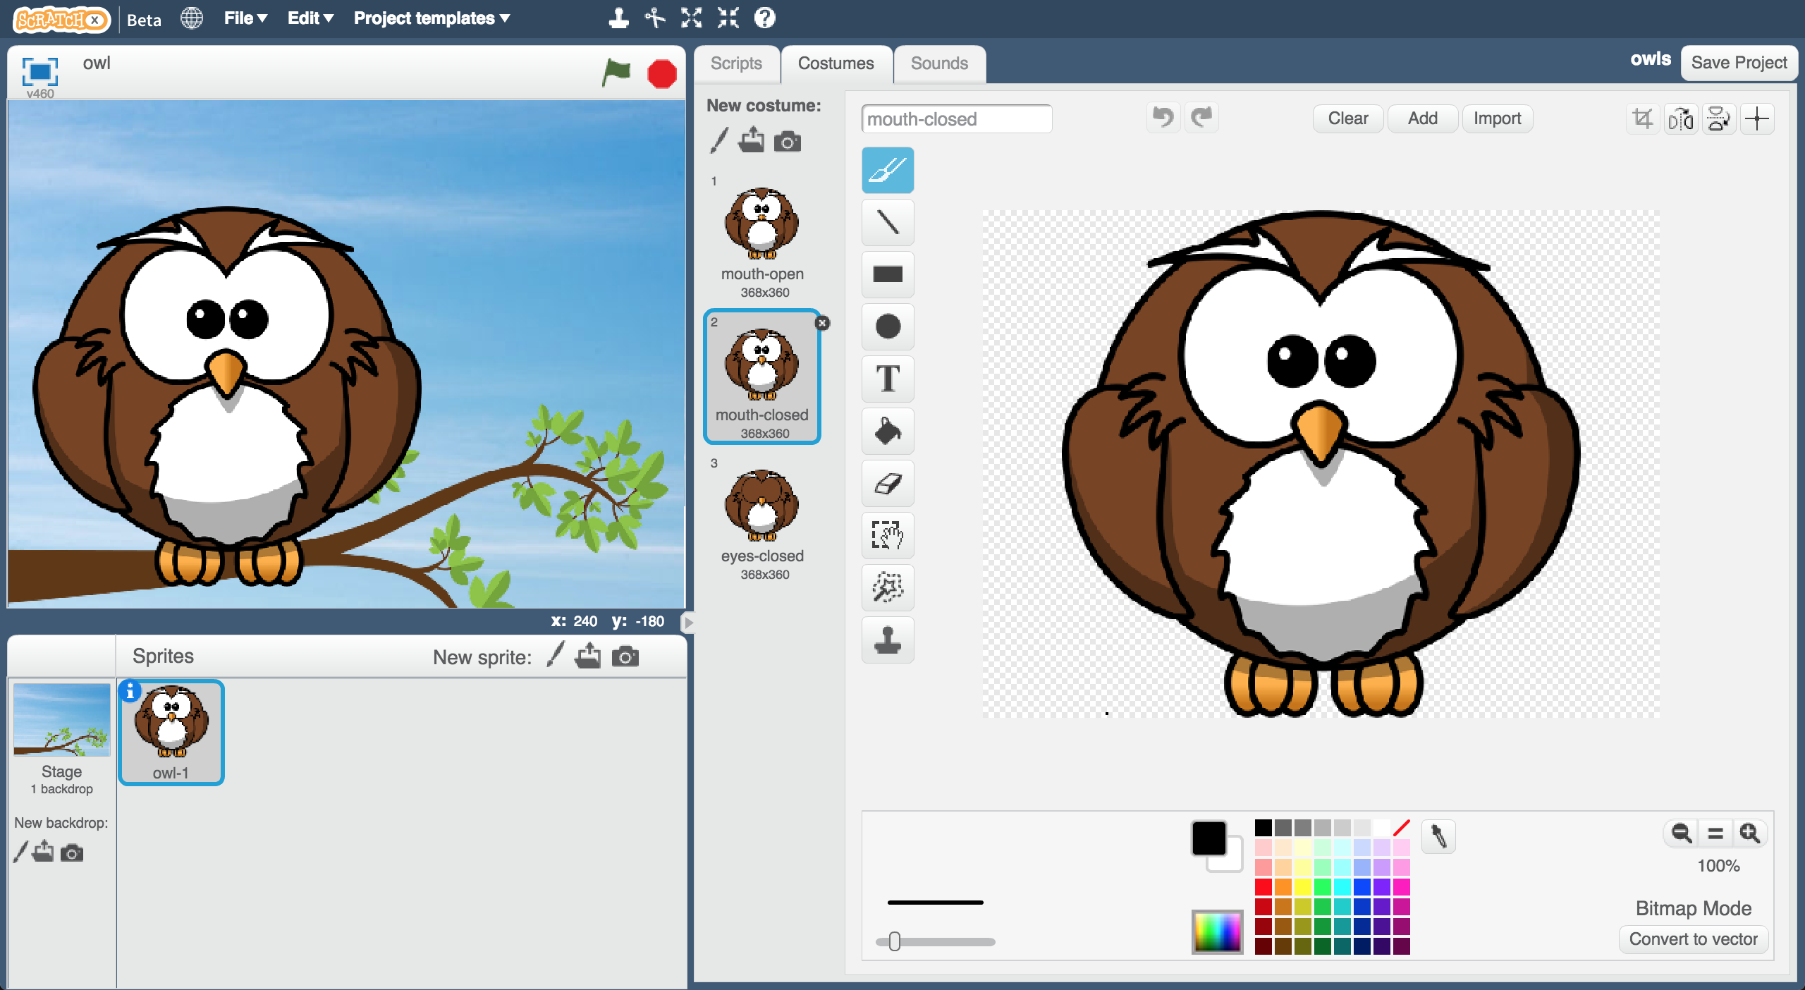*
20. Test your chatbot!  
    *Click the green flag and try asking the owl a question*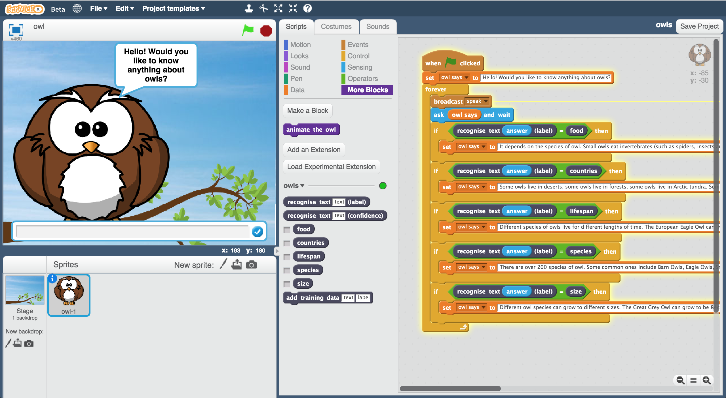

**What have you done so far?**

You’ve started to train a computer to recognise questions on a topic. Instead of trying to write rules to be able to do this, you did this by collecting examples. These examples were used to train a machine learning “model”.

This is called “supervised learning” because of the way you are supervising the computer’s training.

The computer will learn from patterns in the examples you’ve given it, such as the choice of words, and the way questions are structured. These will be used to be able to recognise new questions.

The biggest problem with this is that if you ask it something unexpected, it will still give you one of the answers you’ve written

1. Create this little chunk of script, that you can use when someone asks a question that wasn’t on your list from step 2.  
   *The confidence score is a percentage (from 0 to 100).   
   It will be lower if someone asks a question that isn’t similar to any of the examples you used to train the machine learning model.   
   Use this to return a “I don’t understand” message if the score is too low.*   
   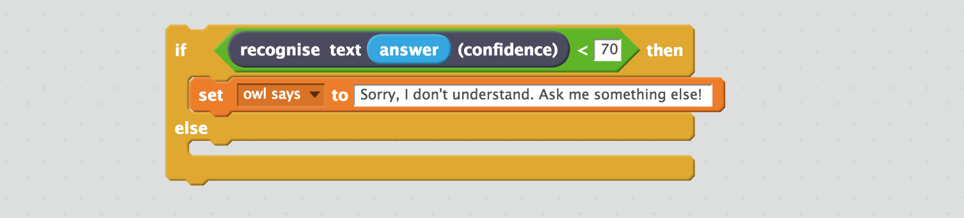
2. Add this into your script from before.   
   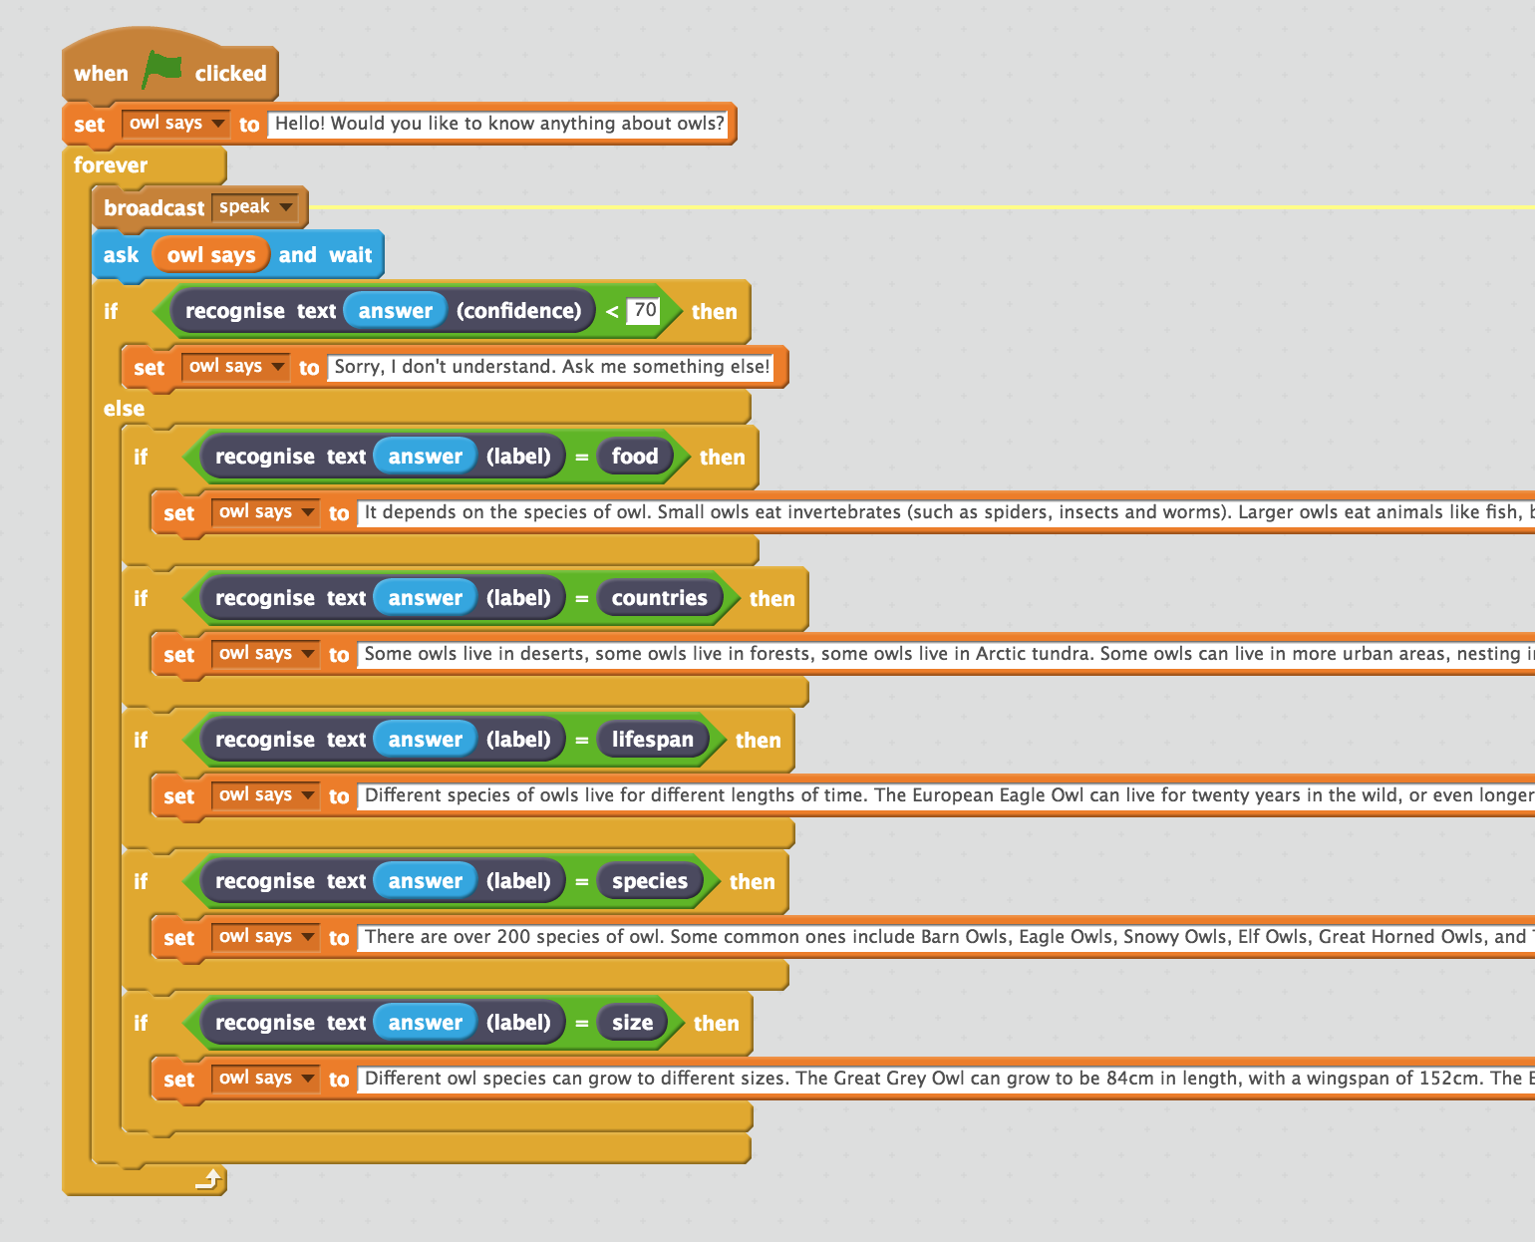

**Ideas and Extensions**

Now that you’ve finished, why not give one of these ideas a try?

Or come up with one of your own?

**Try other chatbots**

<http://talktothetrex.com> is a good example of the sort of thing you’ve made. Give it a try and see if you can get any ideas of how to improve your bot.

**Add more topics**

Can you add more topics to your chatbot, so that there are more types of question that it can answer?

**Provide alternate answers**

If someone asks the same question more than once, they’ll get the exact same answer every time.

Can you update your Scratch script so that it varies the answers each time a little? Or just starts the answer with “You’ve asked me this before, but”

**Ask follow-up questions**

Can you update your Scratch script so that it replies with a question? It can then recognise the answer to that question, in a similar way to how you made it recognise questions.